

**CS 1632 Software Quality Assurance**

**Deliverable 4**

**Name**: Mouhammadou Dabo

(Note: this is an individual project. No groups allowed.)

1. **Optimized Feature 1**
   1. Write the name of the feature optimized (the label on the button)  
      RunContinuous
   2. Write the name(s) of the method(s) you refactored to optimize this feature  
      MainPanel.calculateNextIteration() and MainPanel.iterateCell()
   3. 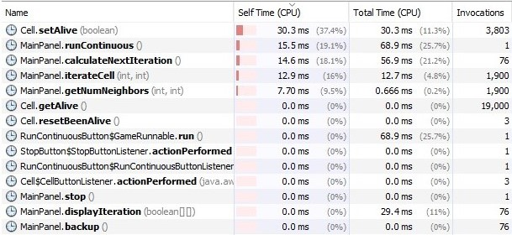
2. **Optimized Feature 2**
   1. Write the name of the feature optimized (the label on the button)  
      Write
   2. Write the name(s) of the method(s) you refactored to optimize this feature  
      Cell.toString()
   3. 